Bug Report Paylocity Benefits Dashboard

1 Scenario 1: Add Employee (UI portal) Wrong Names
Summary:
When a new employee is added, First name and Last name Columns are swapped for the new employee.

Reproduction steps
1- Login with valid credentials to the portal
Expected result: login successful
pass
2- Click on the add employee button
Expected Result: Add employee form is shown
pass
3- Fill all the fields and click Add button
Expected Result: Employee details are correctly added to the table
Actual Result: The first name provided is appearing in the Last name column, and the Last name is appearing in the First name column.
Fail
Evidence:
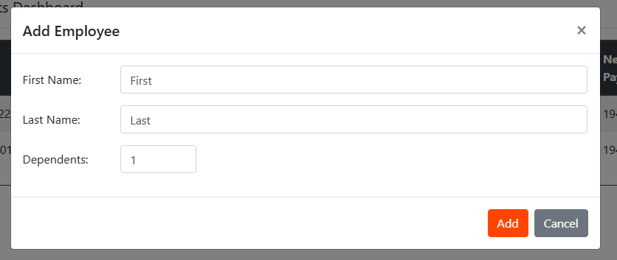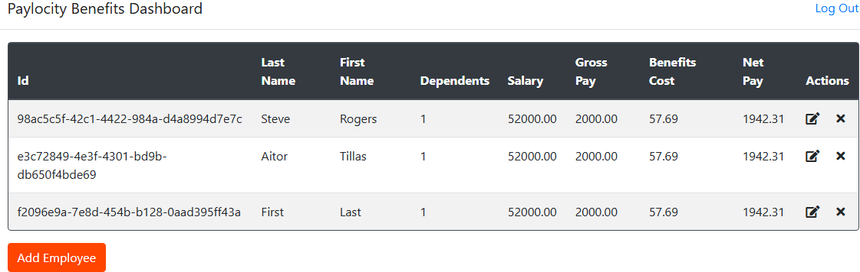

2 Scenario 1: Add Employee (UI portal) no error messages
Summary:
When a new employee is added, there is no clear criteria when an employee fails to be added

Reproduction steps
1- Login with valid credentials to the portal
Expected result: login successful
pass
2- Click on the add employee button
Expected Result: Add employee form is shown
pass
3- Fill all the fields using long names or leaving an empty field and click on Add button
Expected Result: Error message should inform the user, what criteria was not met in order to add an employee correctly.
Actual Result: When the user clicks on Add button, nothing happens, and the user is not added, leaving the user without a hint to know why the employee was not added.
Fail
Evidence: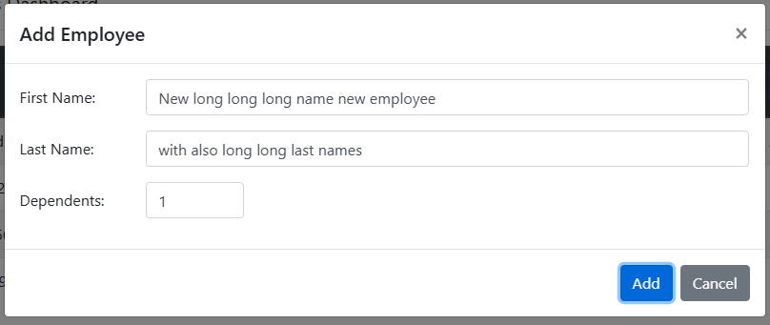
Comment: Same applies for Scenario 2, Update employee

3 API naming mismatch
Summary:
The API name and the UI name for “Dependants” is different.

Description
After API Cal to the following URL using Get Method: https://wmxrwq14uc.execute-api.us-east-1.amazonaws.com/Prod/api/Employees

The API response is the following
"sortKey": "00c8eed6-e379-4bd1-9f8e-3413ae0bdff5",
"username": "TestUser863",
"id": "00c8eed6-e379-4bd1-9f8e-3413ae0bdff5",
"firstName": "Juan",
"lastName": "Perez",
"dependants": 2,
"expiration": "2026-02-08T18:52:14+00:00",
"salary": 52000,
"gross": 2000,
"benefitsCost": 76.92308,
"net": 1923.0769
Observe that the highlighted id is “dependants”; However the UI field appears as “Dependents”
Comment: Could be just a typo or not anything important, but from QA perspective the UI should follow the API naming.

4 Username not required

Summary:
Username field is required in API documentation, but it is auto-completed

Description:
According to the Swagger documentation (section components.schemas.Employee), the username field is part of the "required" array: ["firstName", "lastName", "username"], which indicates that it is mandatory for POST and PUT operations on /api/Employees.

However, when performing a POST without including the username field in the body, the API responds with a 200 OK and successfully creates the employee. Instead, the backend automatically assigns the username extracted from the Basic Auth authentication credentials (in this case, "TestUser863") as the value for username.
This violates the API contract defined in the documentation and allows the creation of records with incomplete or unexpected data.

Reproduction steps:
1 create a call using put or post using the following format:
json
{
"firstName": "Dummy data",
"lastName": "Dummy data",
}
Expected result: error code 400 (Bad Request)
Actual result: Register is created, and Username field gets autopopulated using Auth credentials
Fail
Evidence:
